**Experiment 2.1**

**Student Name: Rahul Kumar UID: 20BCS7081**

**Branch: CSE Section/Group: 716/B**

**Semester: 6th Date of Performance: 28 March 2023**

**Subject Name: CC lab**

**AIM:**

Implement the concept of **Tree**.

**Objective:**

1. To learn Tree
2. Data structure is used to implement the of Tree.

**Requirements:**

Vscode , leetcode , PC or Laptop ,etc.

**Code And Output:**

**Question 1-**

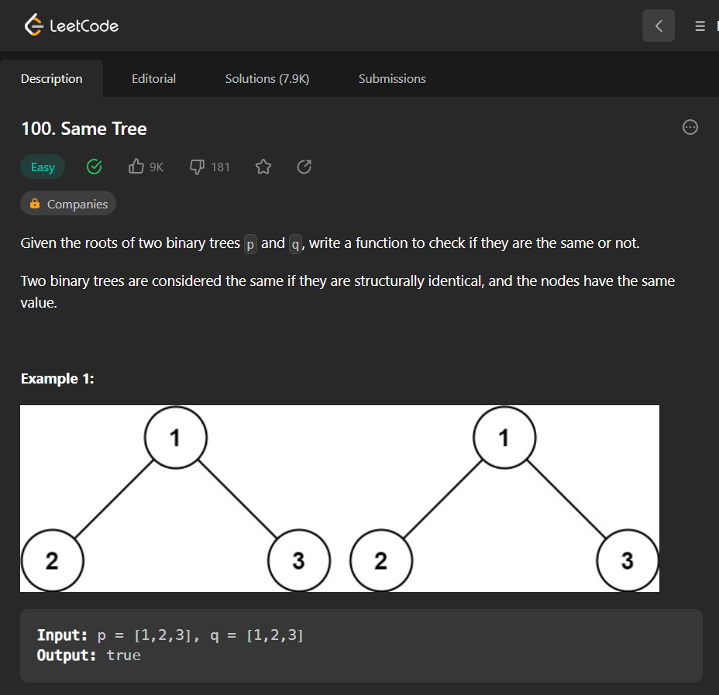

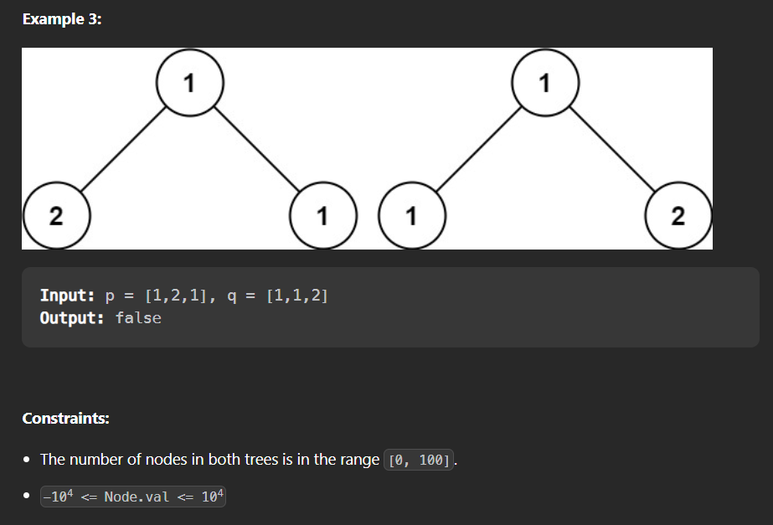

**Answer –**

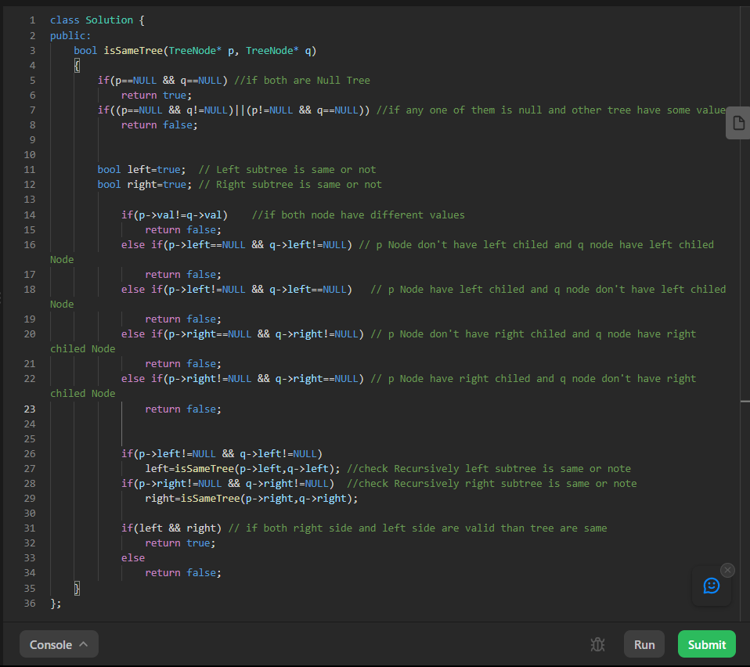

**Question 2-**

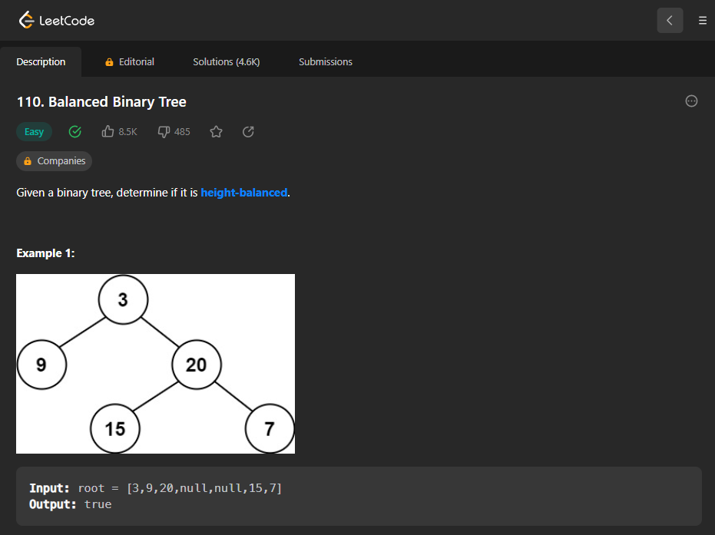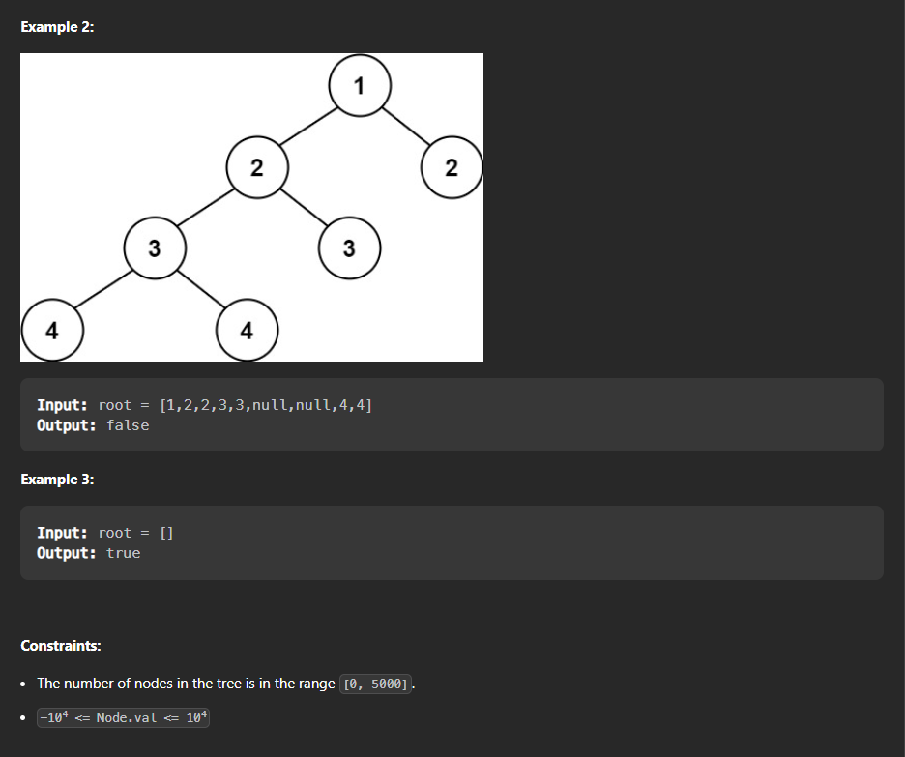

**Answer –**

